**Database Management System Mini Project**

**Title: One Click Payment**

**Team members:**

PE 26 Kshitish Deshpande Panel 5

PE 35 Manas Kumar Mukul Panel 5

PE 50 Kashyap Kale Panel 5

PE 47 Reet Agarwal Panel 5

**Motivation:**

In a world that works with no buffering time, the current net banking system is considerably slow due to security concerns (mainly due to one-time password service employed). Also, few areas have a low network connection for them this method is an alternate solution.

**Problem Description:**

The system maintains data of ***BANK***s. Each bank has a ***bank ID*** & ***name***. A bank account necessarily ***IS OF*** a certain *bank*.

Each bank ***ACCOUNT*** has an ***account number***, ***name***, ***pin*** & ***balance***. A bank *account* can be a ***CURRENT*** account or a ***SAVINGS*** account. Each *savings* account has a certain ***interest rate***, while each *current* account has a certain ***service charge*** associated with it.

A *account* can perform a ***TRANSACTION*** with another *account*. Each *transaction* has a ***transaction ID***, ***amount transferred*** & ***timestamp***. Multiple *accounts* can perform *transactions* with multiple *accounts*. These transactions are carried out by an application (the one click payment system).

The application has ***USER***s. Each *user* has a ***user ID****,* ***name****,* ***password***& ***authorization keys***. Each *authorization key* is of a certain **type** & has a certain **value**. A single *user* can have multiple *authorization keys*. A *user* ***AUTHORIZES*** an *account* so that it can perform a *transaction*. A single *user* can *authorize* multiple *accounts*, & a single *account* can be *authorized* by multiple *users*.

**Objective / Aim:**

* The aim of the project is to reduce the amount of time it takes to make a payment using internet services.
* The method employed to facilitate this is usage of biometric scans to replace one-time passwords. The current project is a prototype with a clunky UI, however the database supporting it is complete.
* Our solution works as a third-party application to support current net banking infrastructure.

**Software /Hardware Requirement:**

We need the following requirements for the project:

* Java
* MySQL
* Json library for Java
* MySQL connector for Java
* Darcula Look and Feel library for Java

**Functional Reqiurement:**

The ERD for our project is as follows:

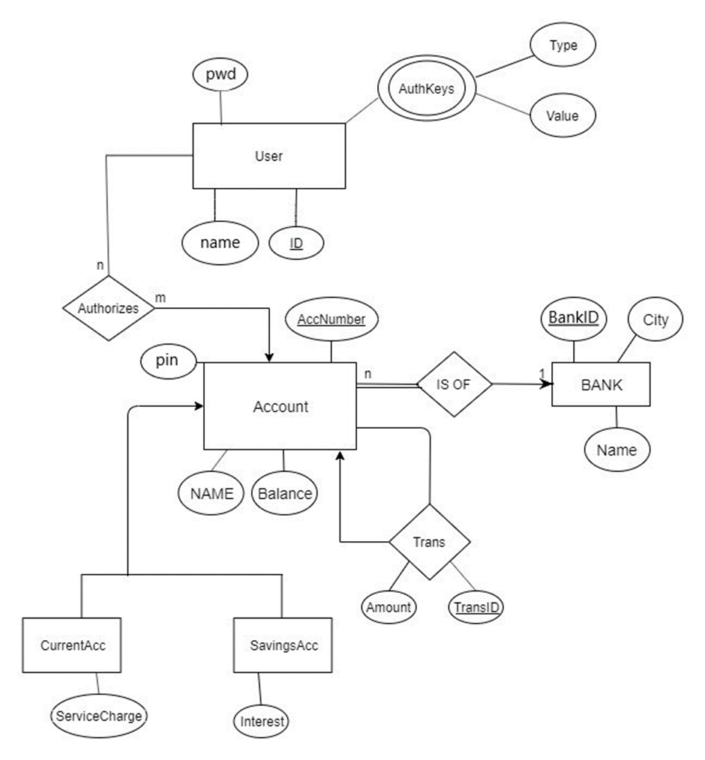

The schema for the database is as follows:

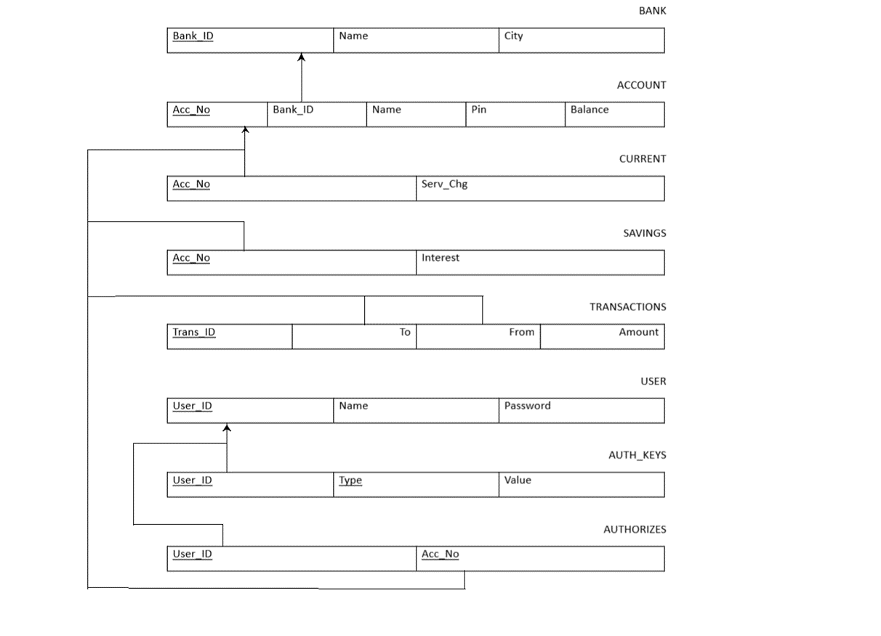

**Innovativeness/Usefulness:**

The project’s aim is to reduce the amount of time it takes to make a payment using internet services. The method employed to facilitate this is usage of biometric scans to replace one-time passwords.

We have implemented a server in the backend to support the functionality of the application along with security. For the same reasons, any and all operations pertaining to the bank take place on a second server which is controlled by the bank. Both the application and the bank access the database using respective users, each having their own privileges to access, modify and/or delete data in the database.

**Current status of Development:**

The prototype has been tested with dummy values for the biometrics, the database is sturdy enough to support the prototype. The servers implemented can successfully modify the database according to the user’s requirements.

**GUI Design :**

This is our login page .

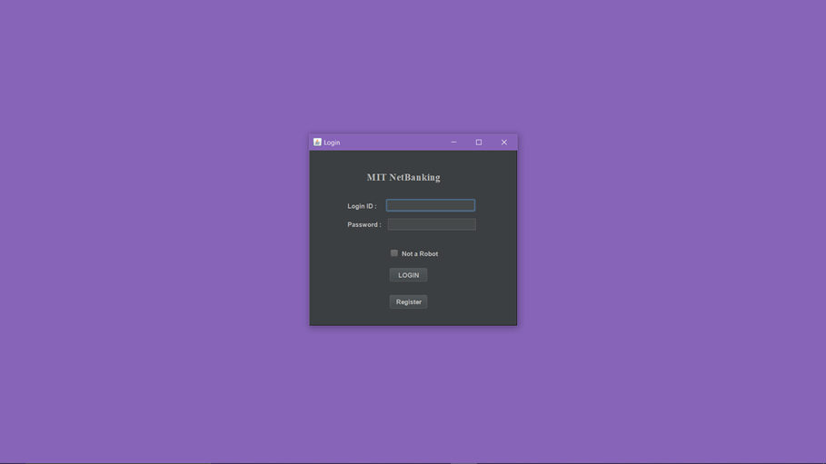

If the user does not tick ‘Not a Robot’ it will show an error. Even if the user is not registered it will ask the user to register first

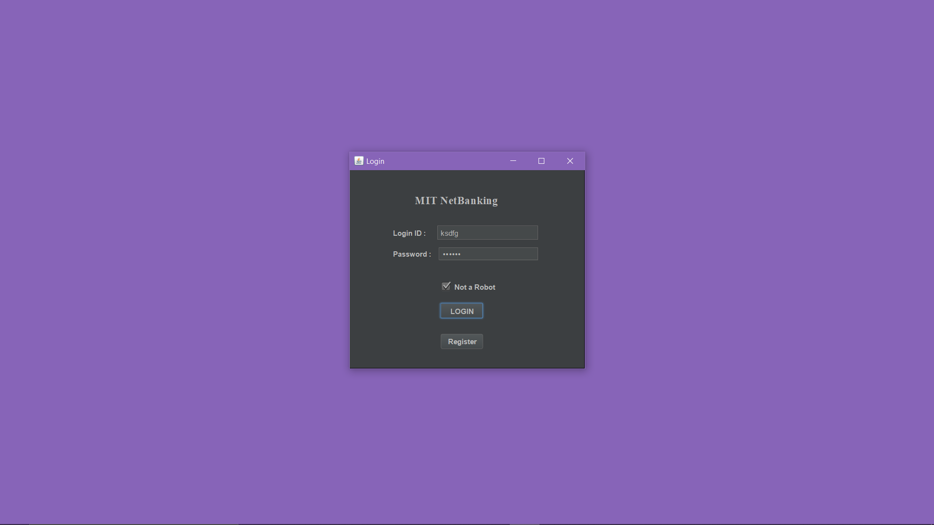

If the password is wrong it will display an error message.

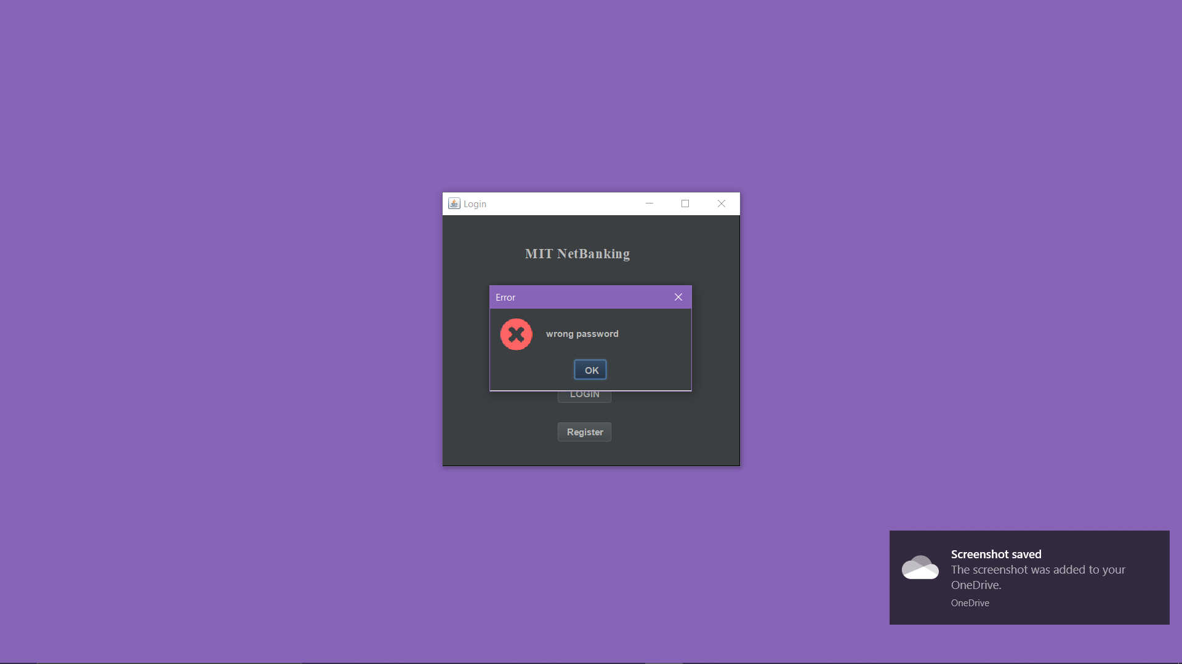

If everything is entered right it will take you to the homepage where the user can choose to either link account , unlink account ,add biometric, remove biometric , change name , change password or to either proceed to pay.

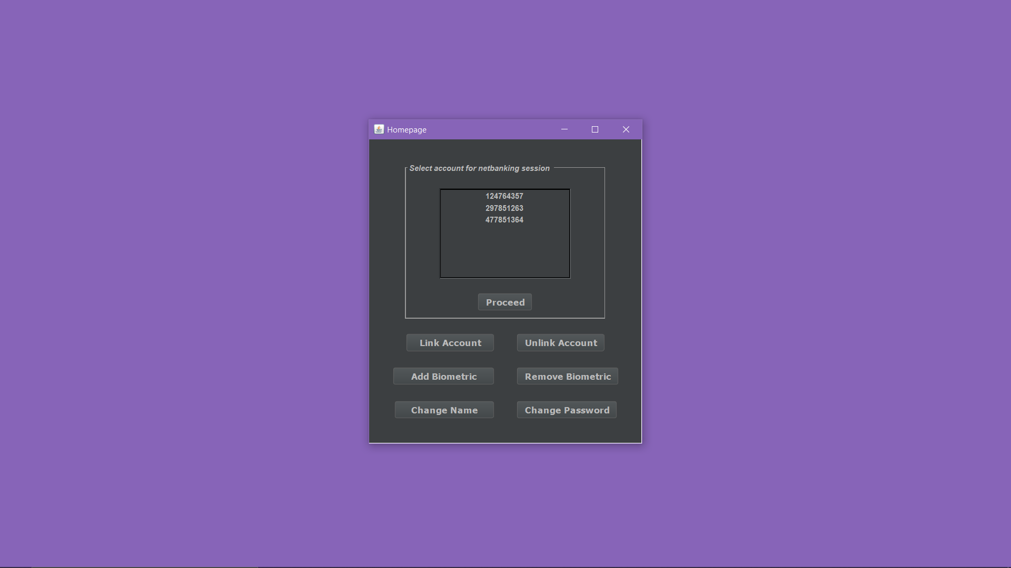

Here now the user has chosen to link an account option.

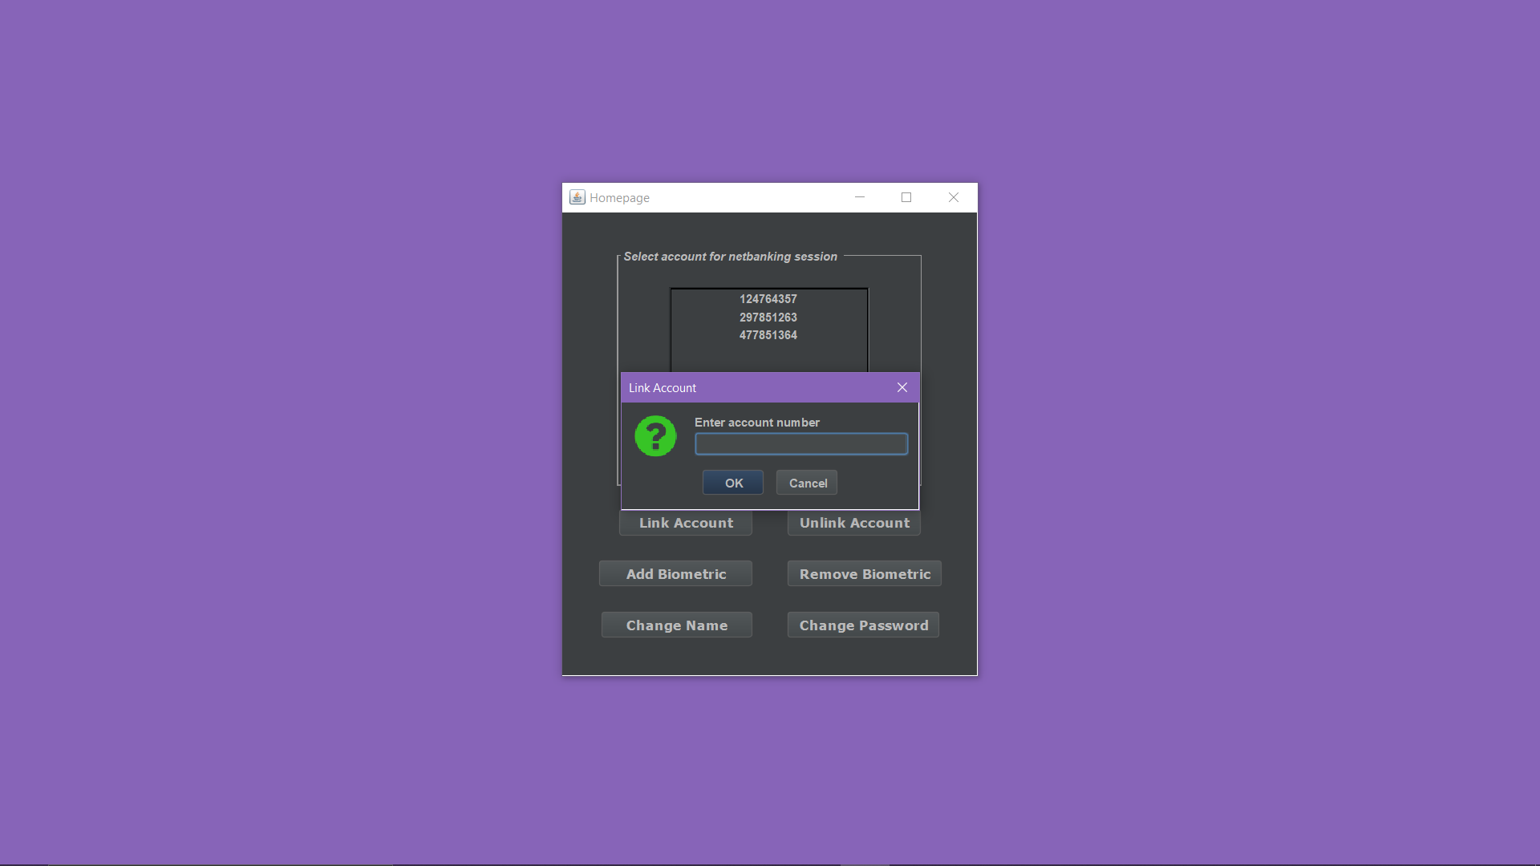

To link the account the user will be sent an one-time password he has to enter that to confirm the linking of the account.

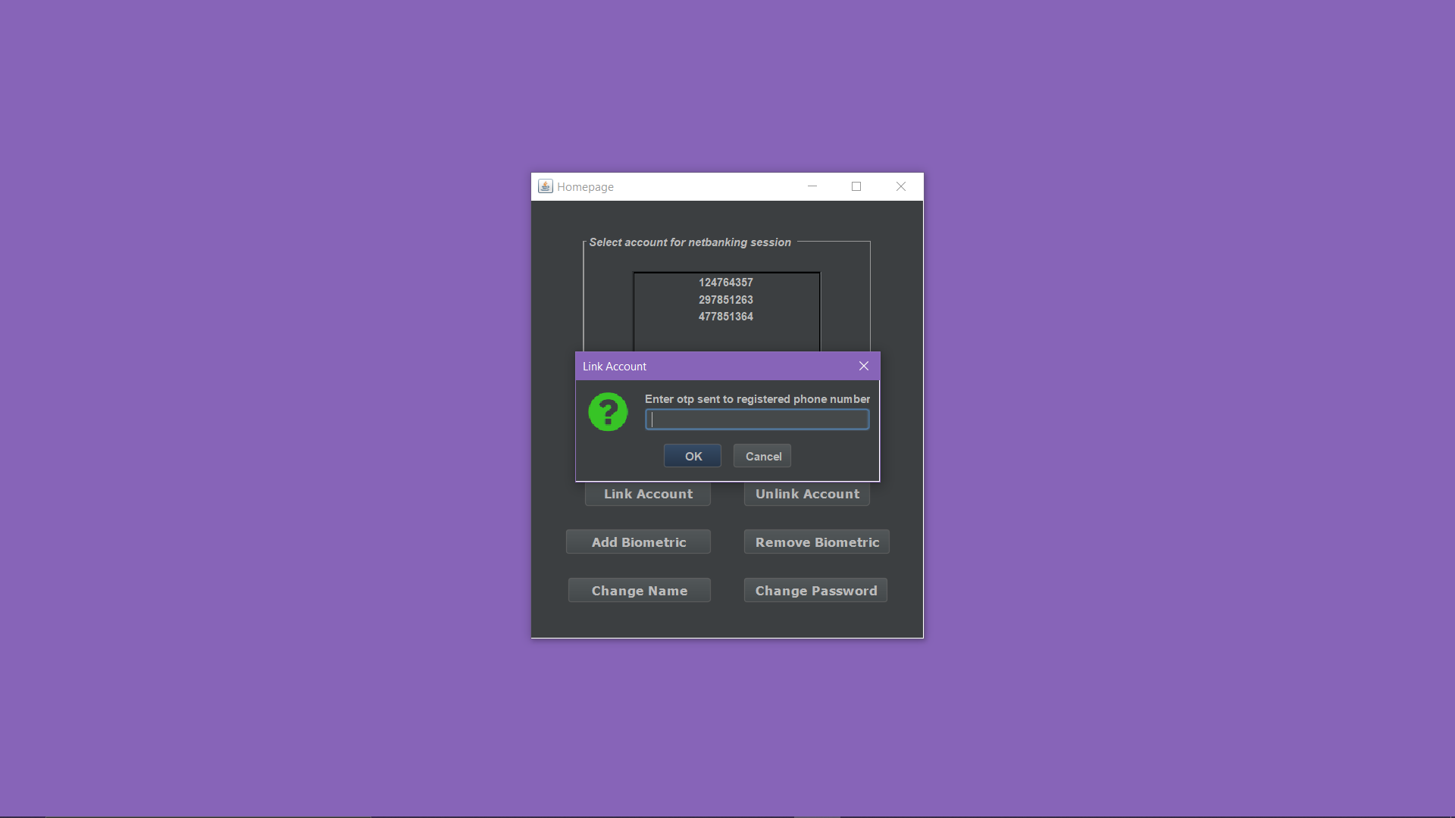

This shows the message that the account has been successfully linked.

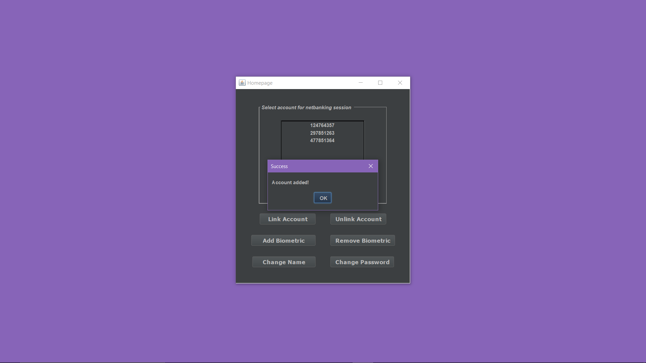

Now the user chooses to remove an account that was previously linked.

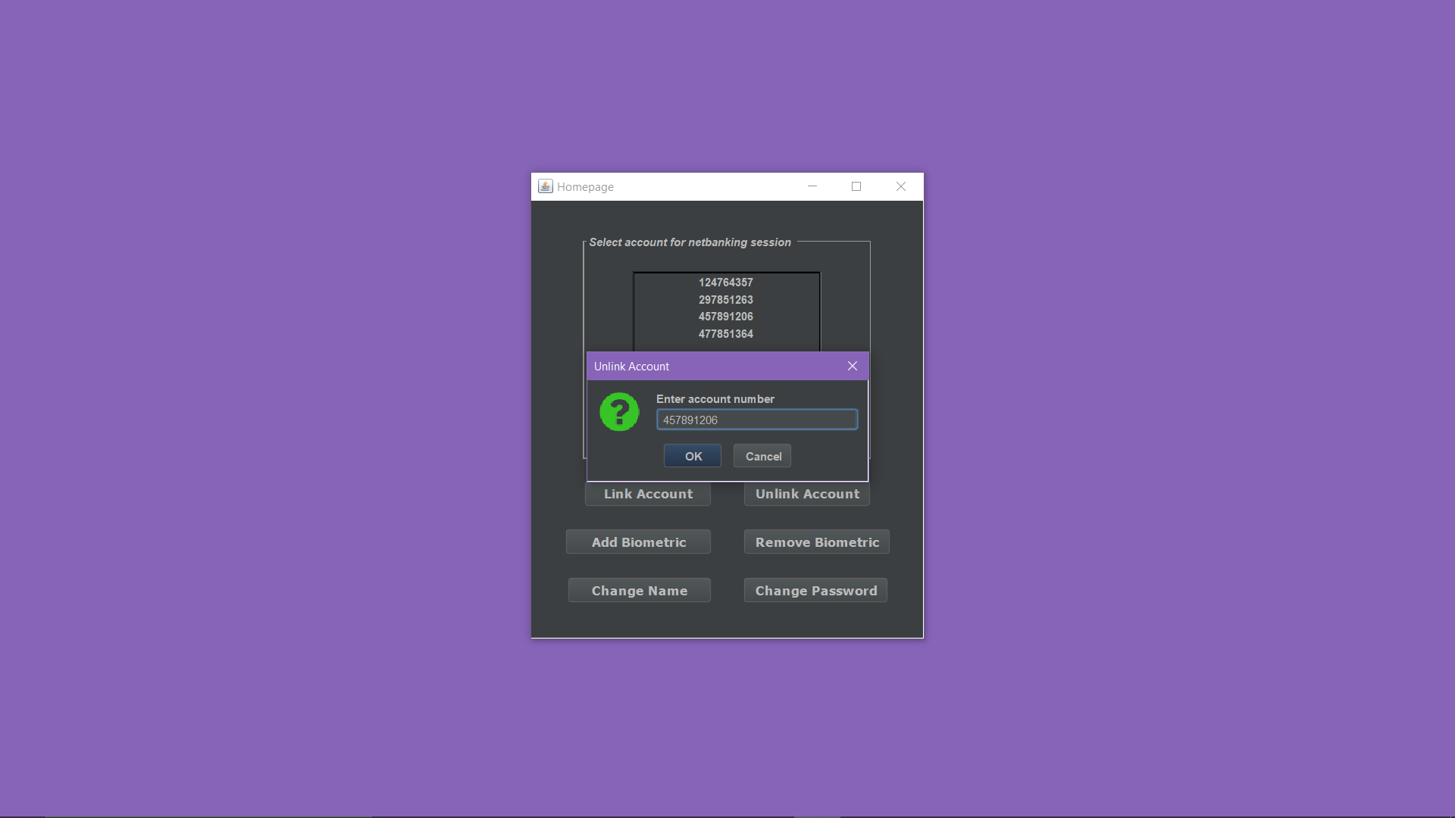

This shows the message that the account has been successfully removed.

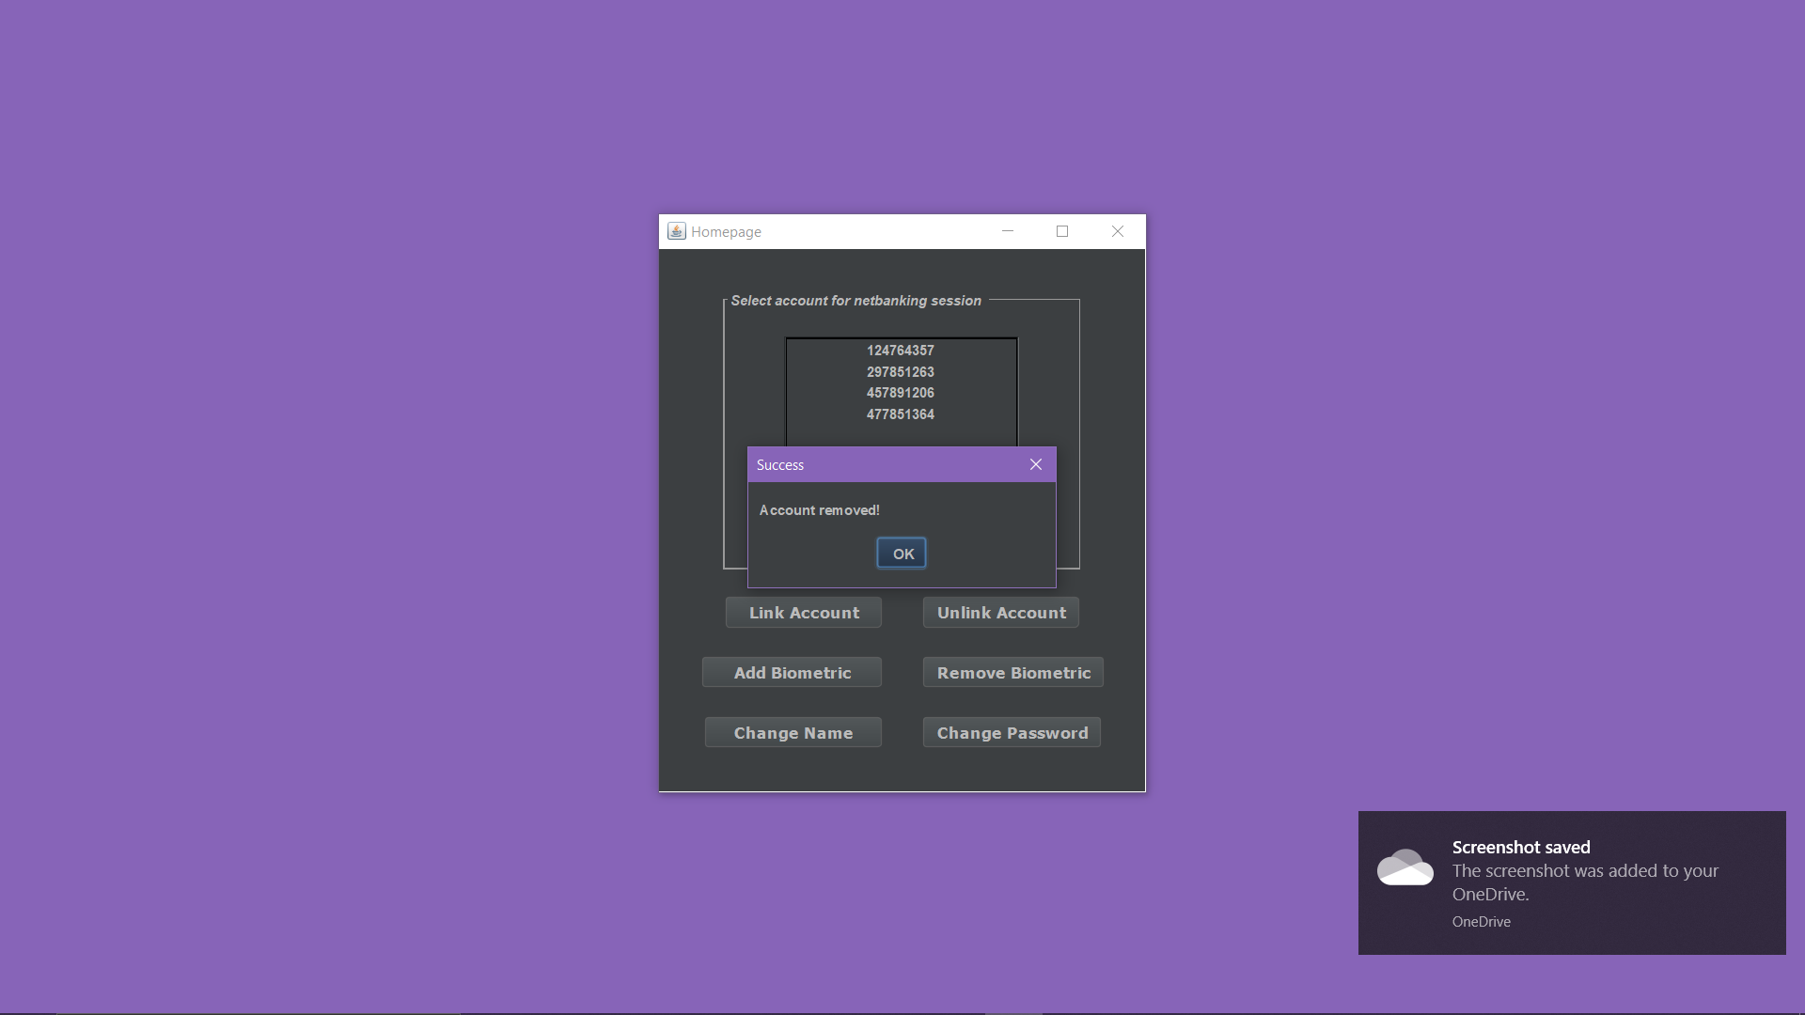

Here the user has chosen the option to add a biometric value.

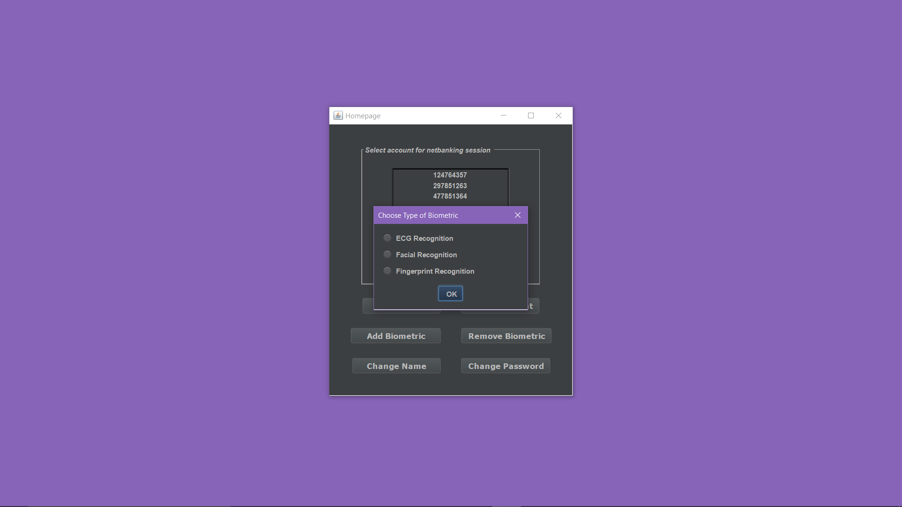

Now the user has to enter a value to be added as a biometric value.

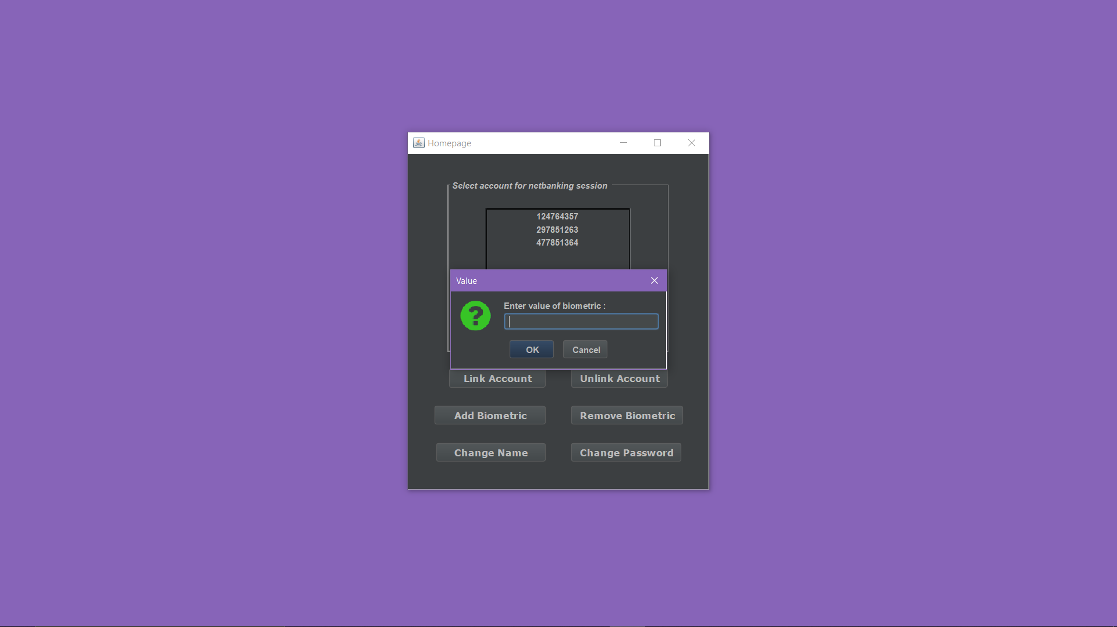

Message is shown that biometric is successfully added.

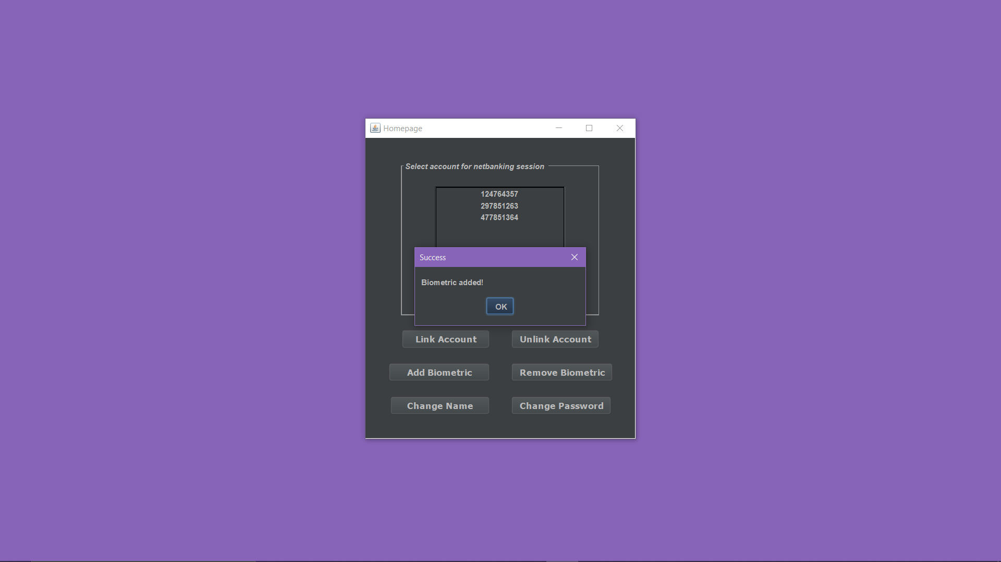

Now the user selects to remove a biometric he had previously added. Here he selects to remove the ecg recognition.

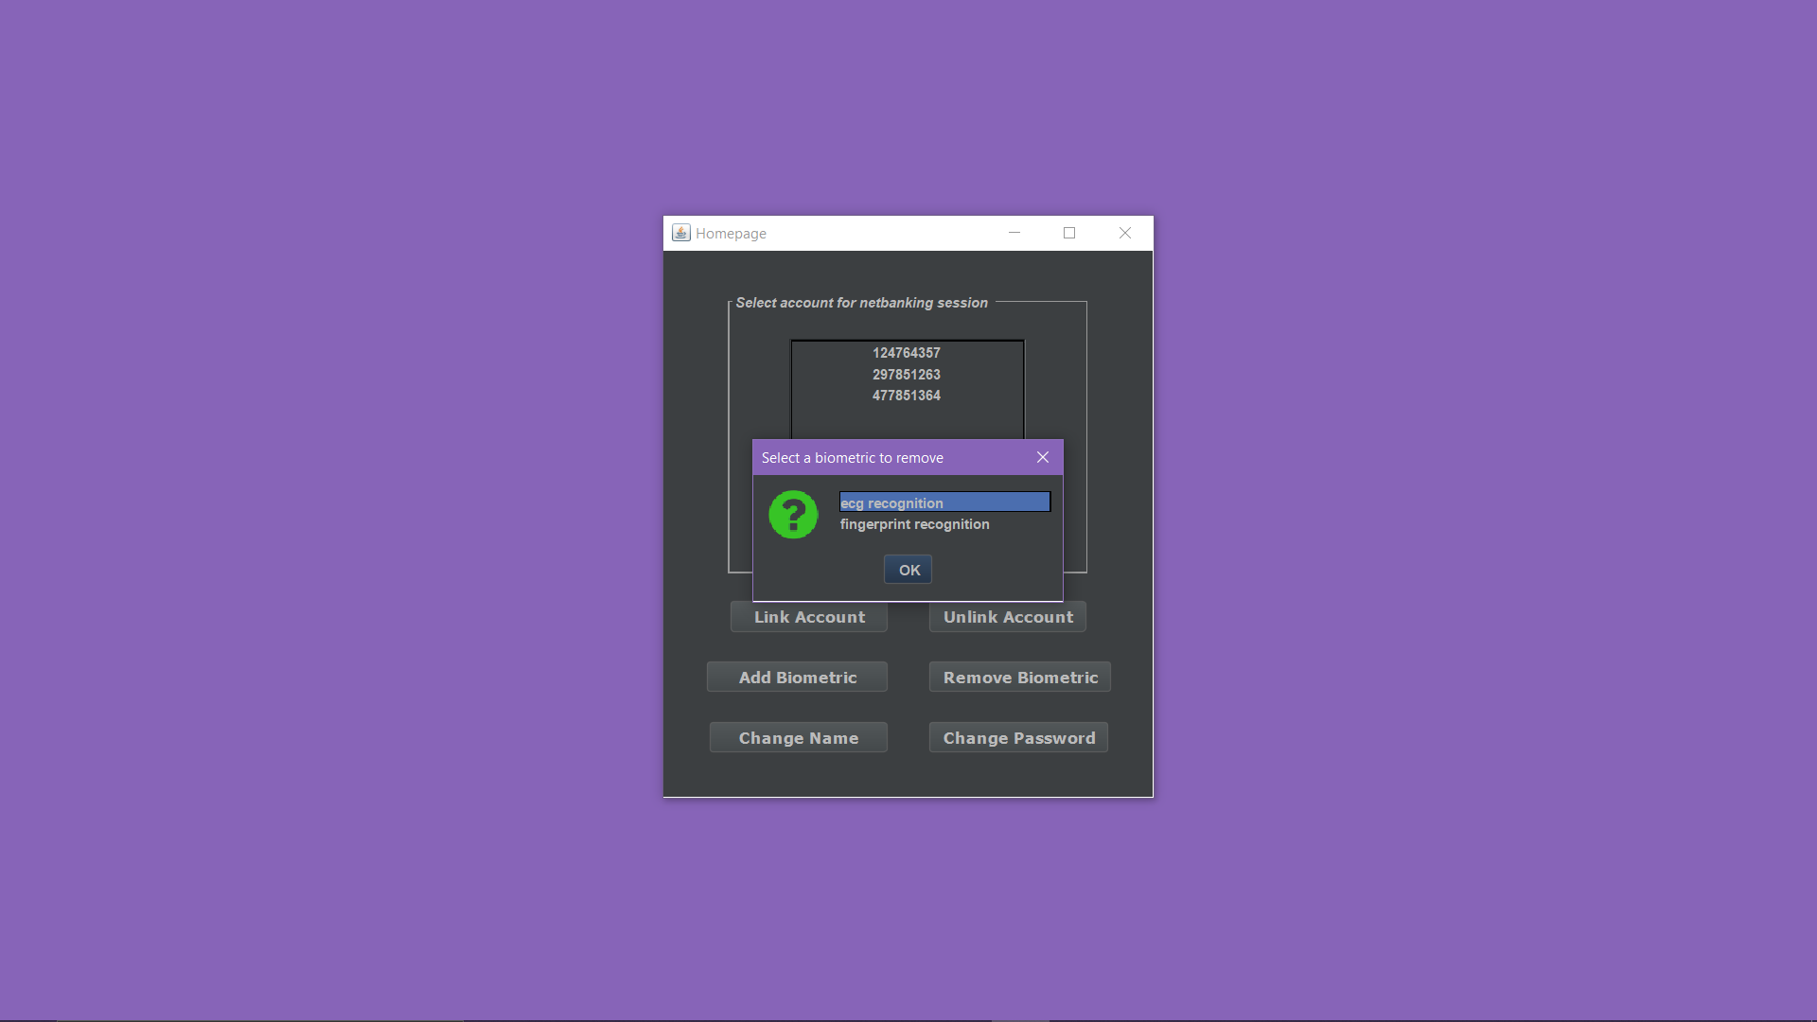

Message is displayed that successfully the biometric has been removed.

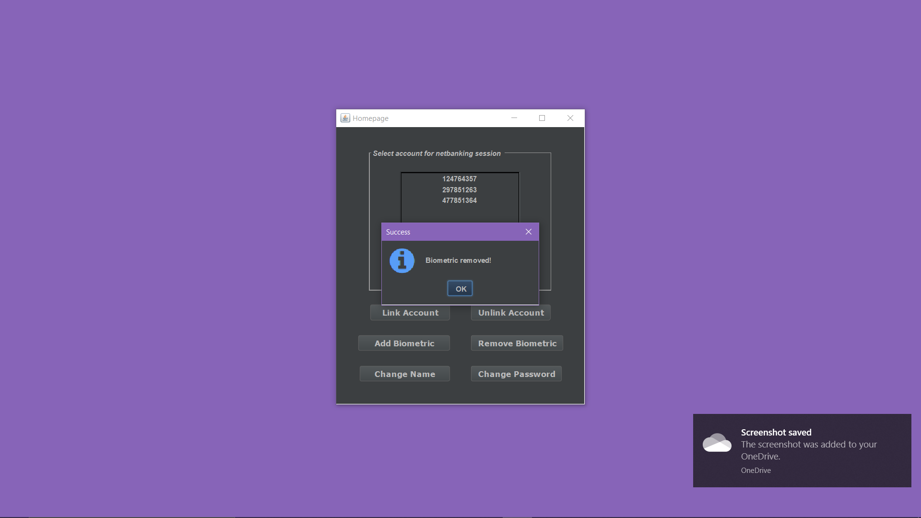

Change name operation is now selected by the user.

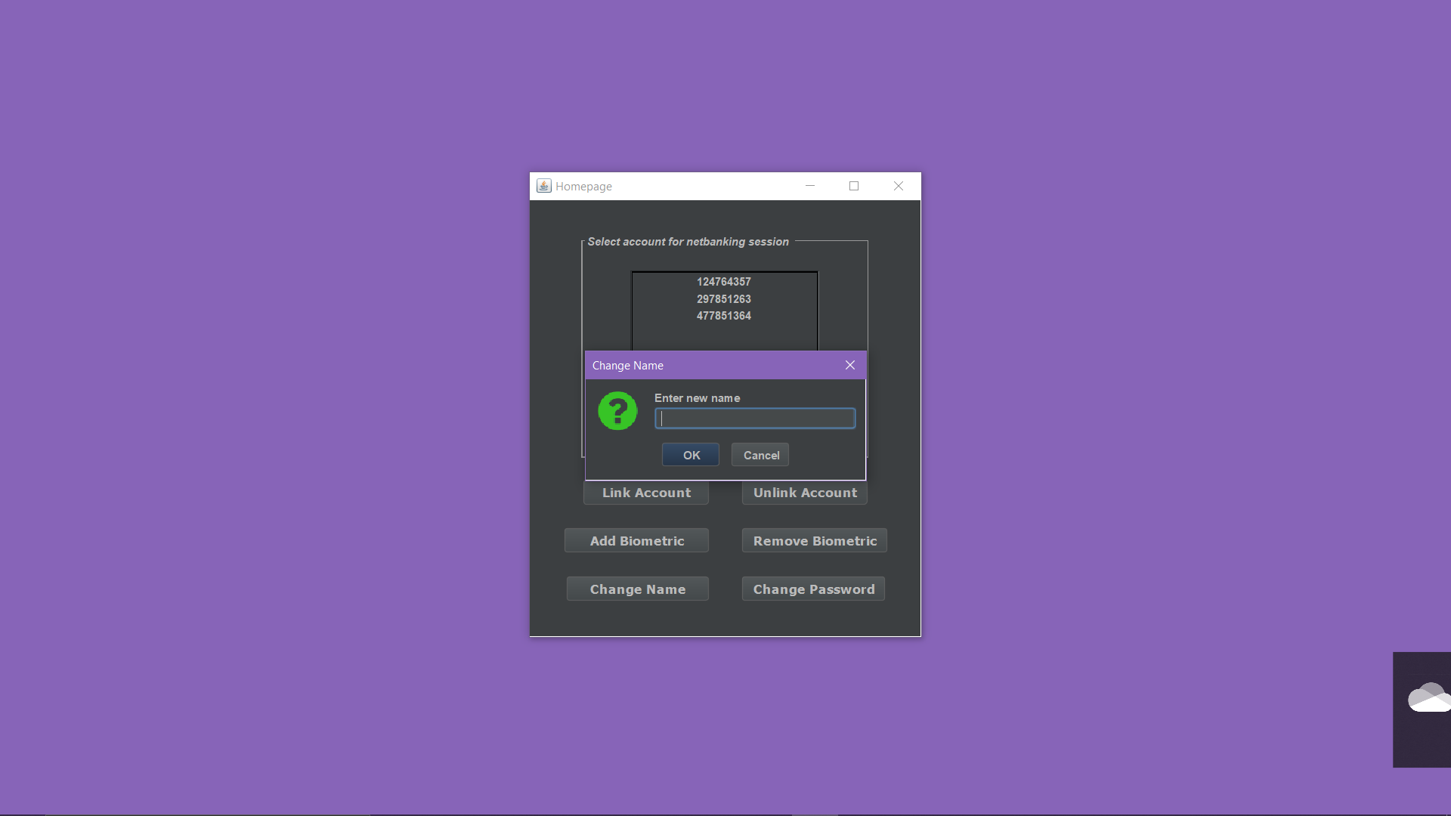

Displays the message that name is successfully changed.

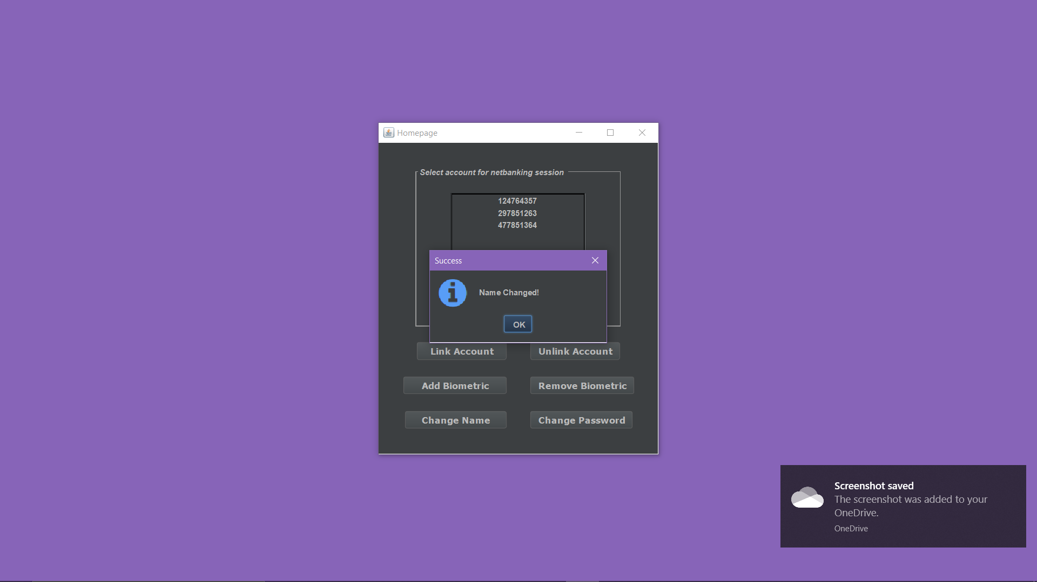

Now the user selects to change the password.

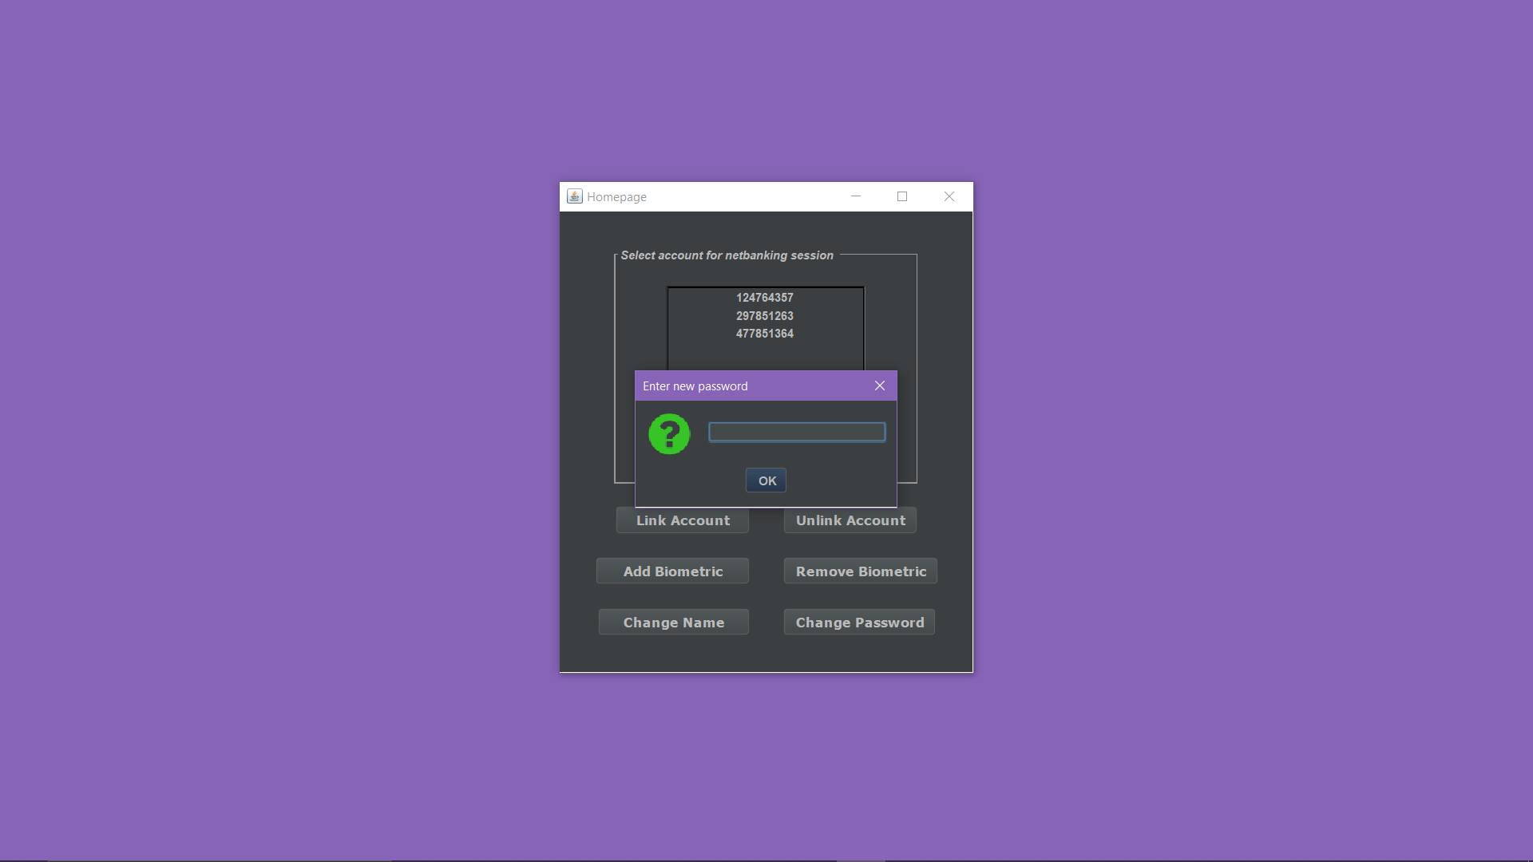

Displays the message that password is successfully changed.

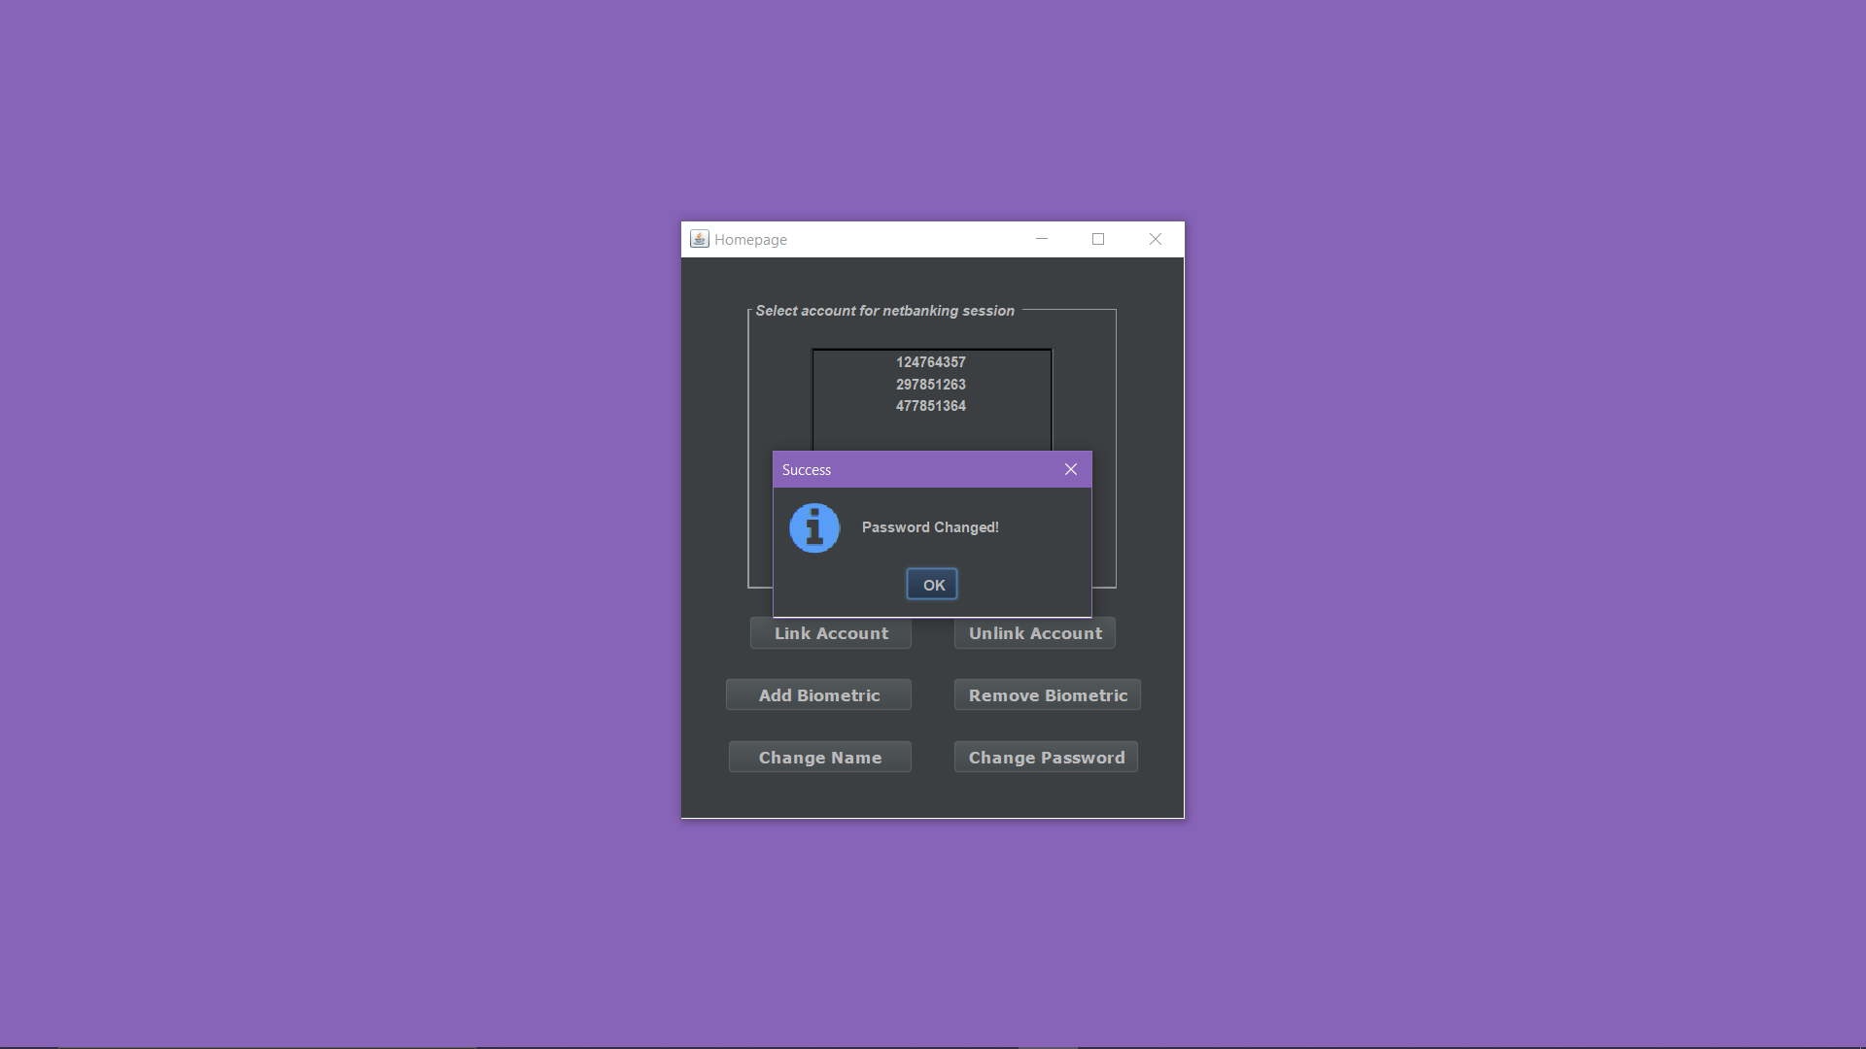

Now the user has to select a bank account to make a payment to .

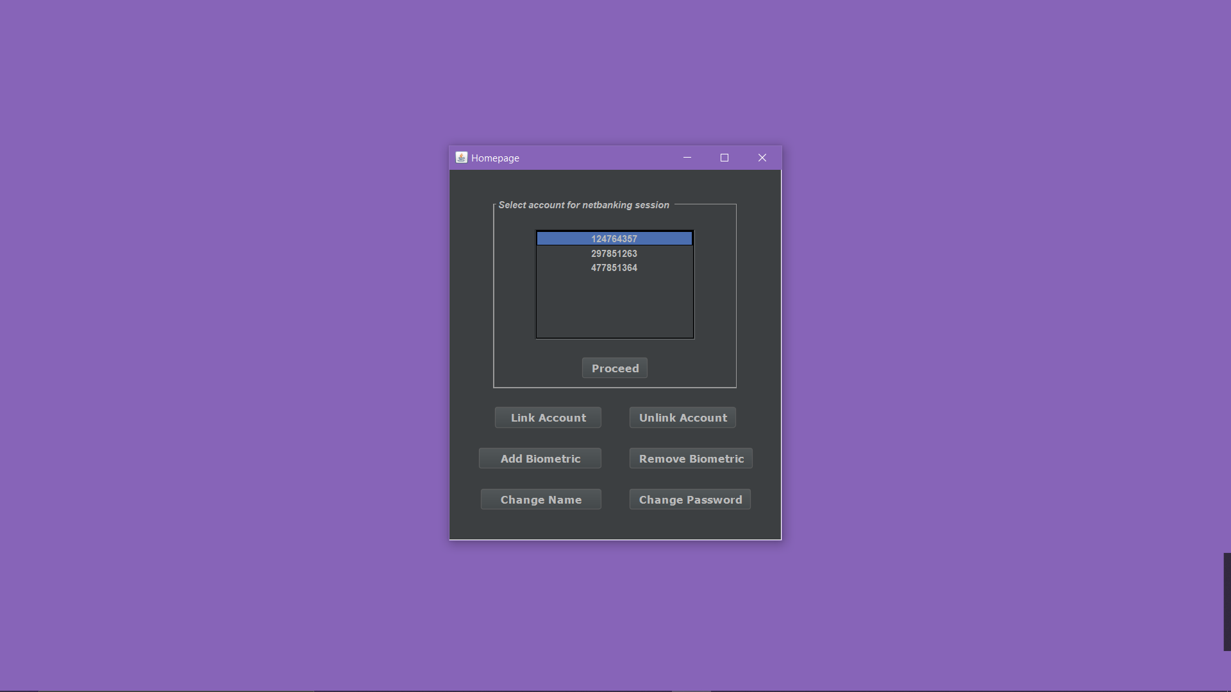

Once the account is selected it will direct you to the transaction page . Here the amount sent is in – and the amount received is in + .

Once pressed PAY it asks the user to enter the amount he wants to pay.

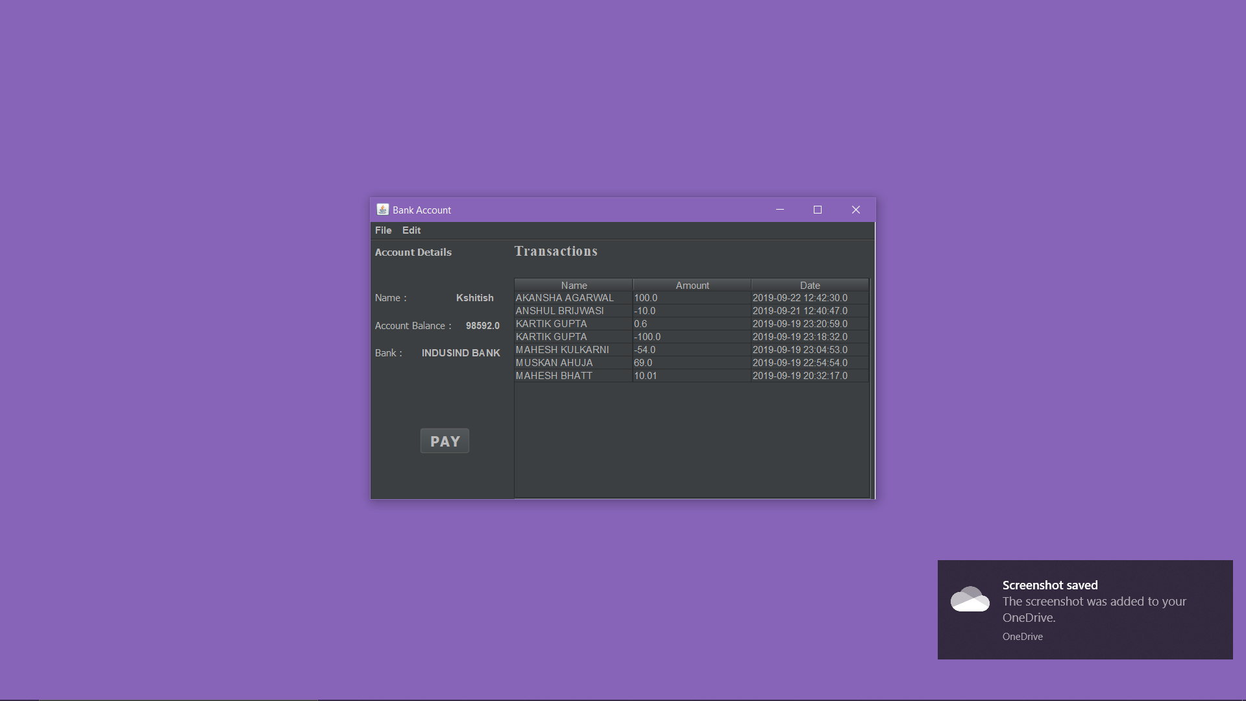

It tells user to enter the account number he wants to pay to and also the amount. It will verify the user by using biometrics.

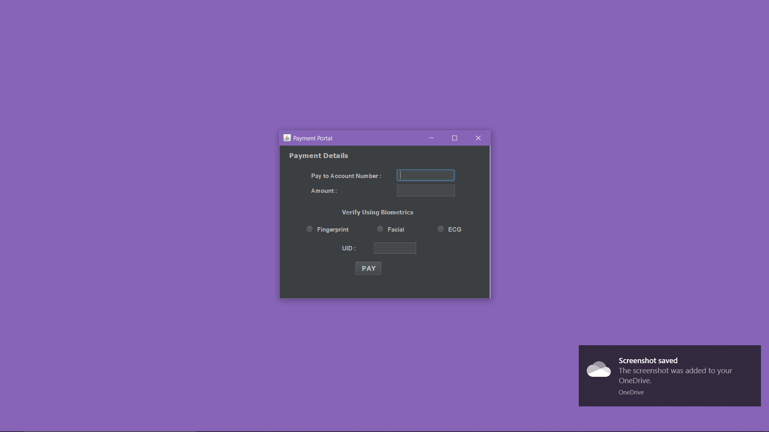

It asks user to enter the pin sent to him.

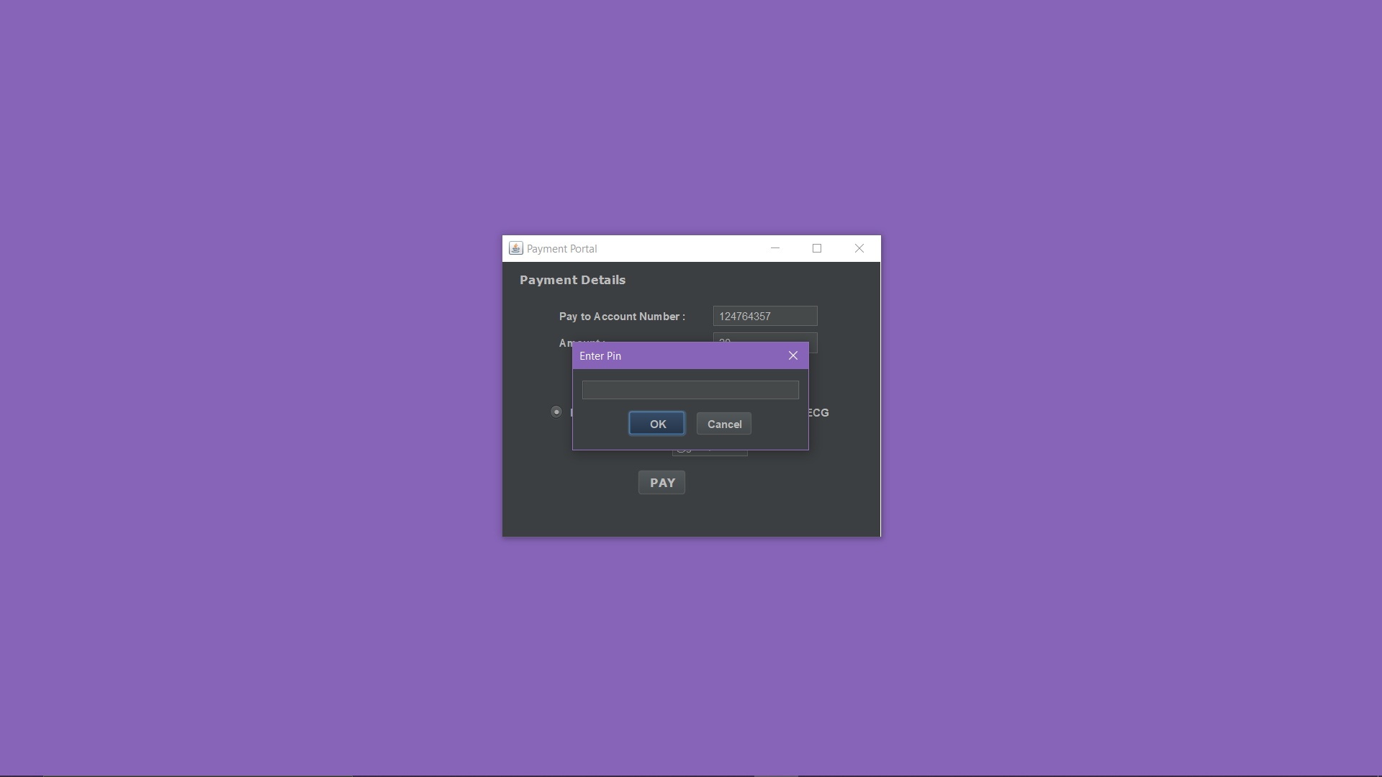

It displays the message that payment is successful.

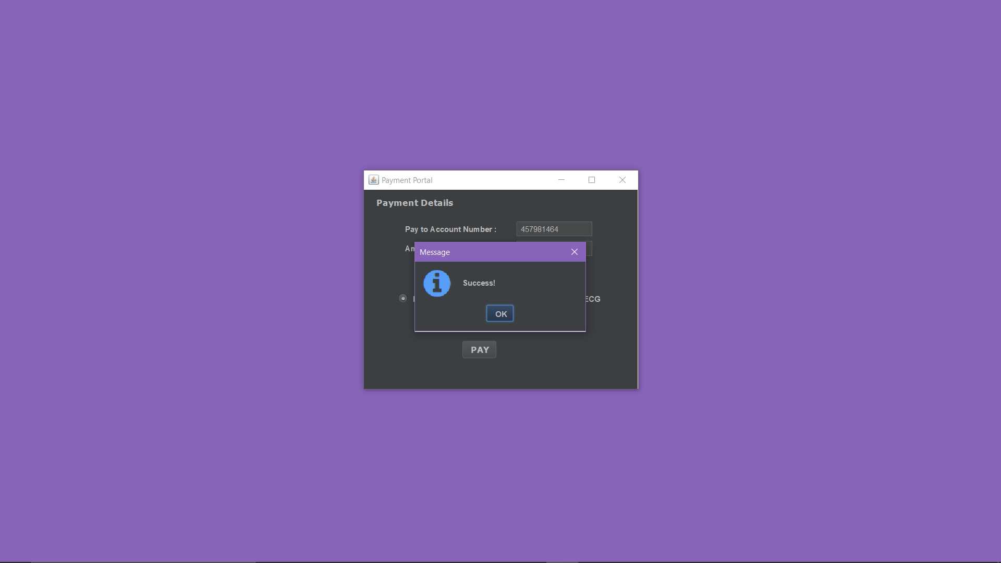

Here in our transaction page it updates the transactions that a particular user has made.

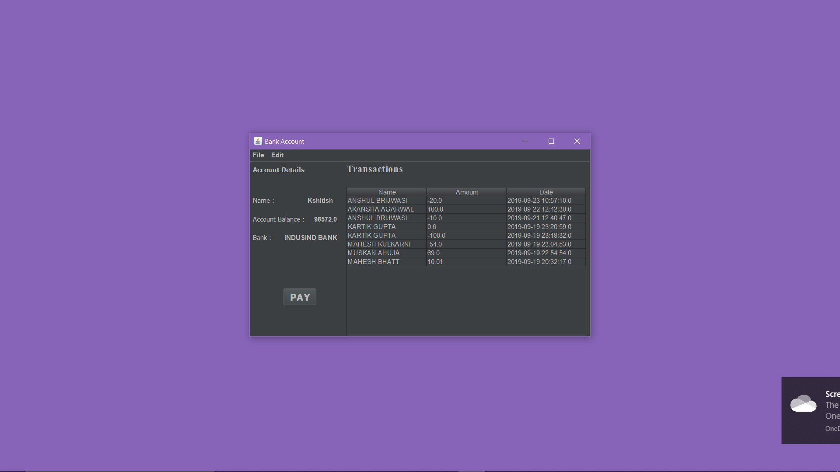

Now once the user cancels this window he is redirected to our homepage from where the user can now exit.